📊 AUDUSD (H1) — Decision
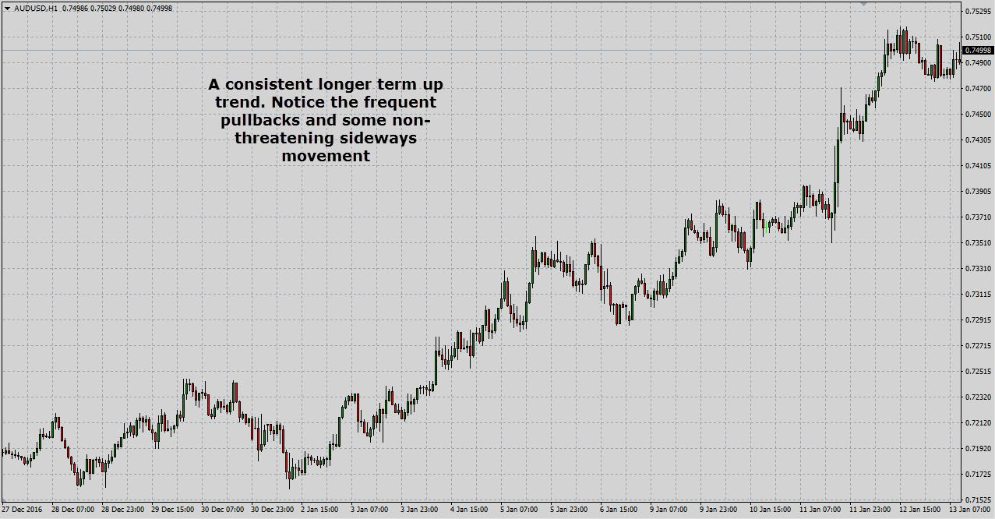
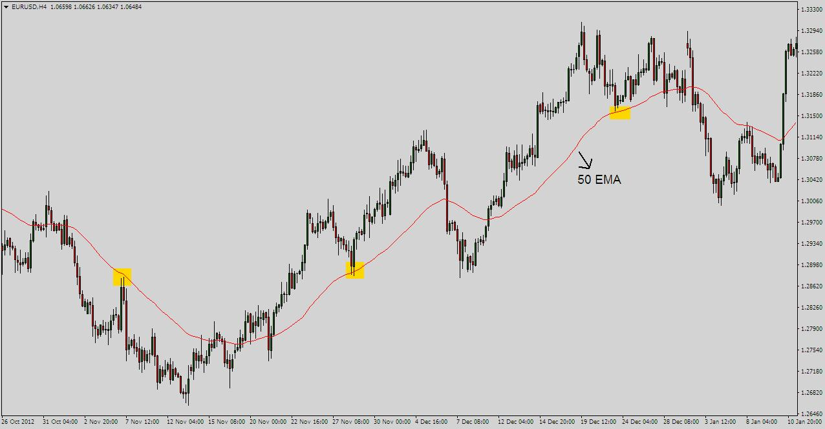
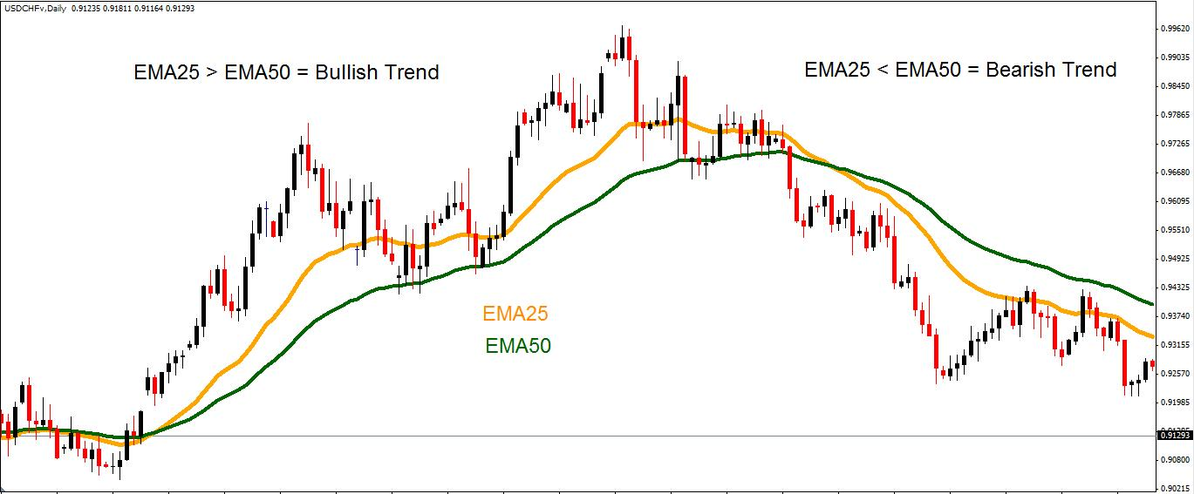
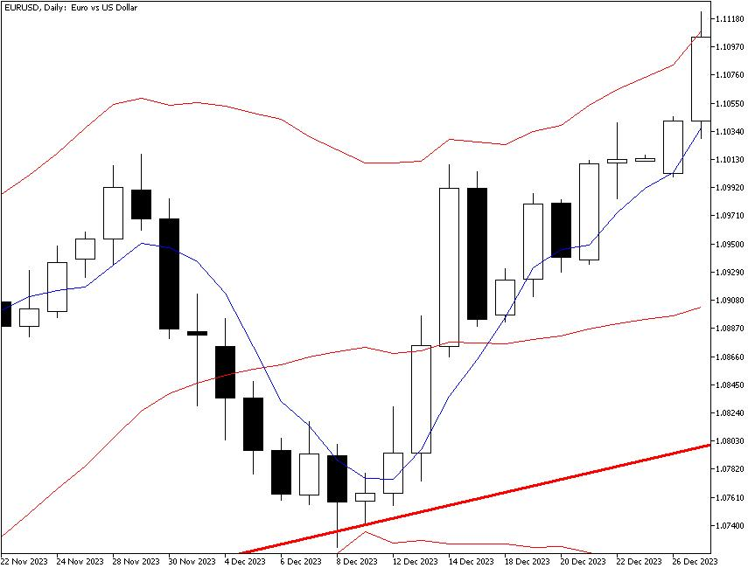
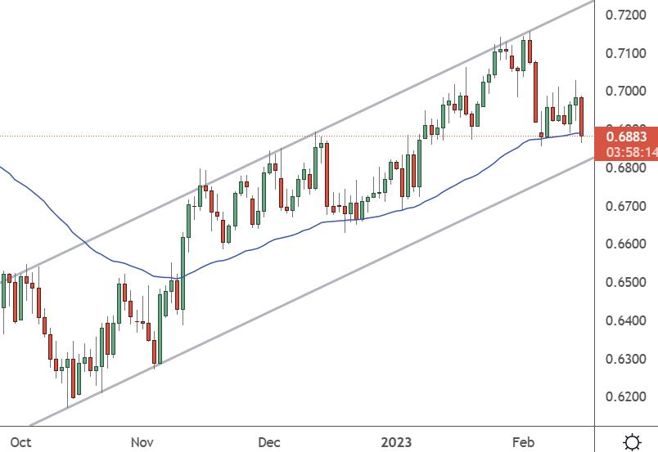
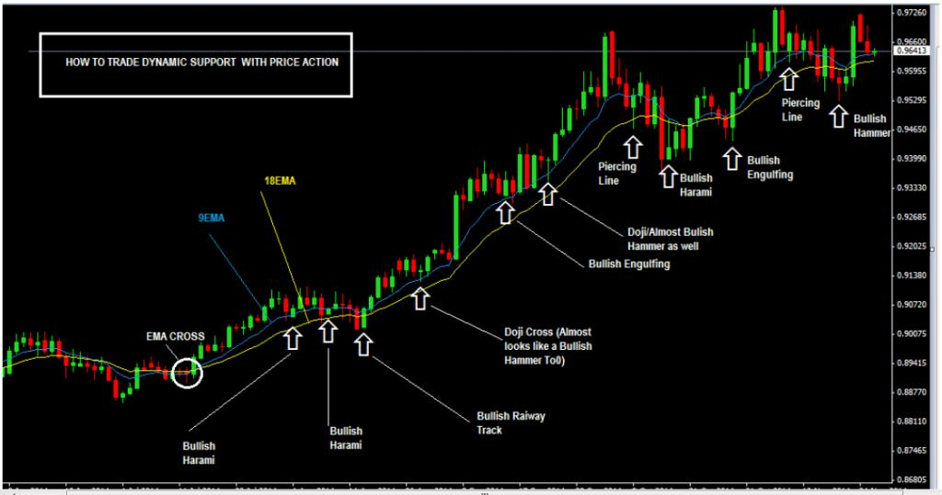

✅ What I’m Seeing
- Price is clearly trending up (higher highs & higher lows)
- Price is above EMA 50 (red) → bullish momentum
- EMA 50 is above EMA 200 (blue) → confirmed trend shift
- Strong bullish push recently (impulse move)
👉 This is a BUY market structure

⚠️ But Timing Matters (Very Important)
Right now:
- Price is near recent highs
- Market has already made a strong move up
👉 That means:
- ❌ Not a good place to enter blindly
- ⚠️ Risk of pullback / short-term retrace

🎯 Best Trade Plan

🥇 Option 1: Wait for Pullback (SAFEST)
Wait for price to:
- Come back to EMA 50 (red line)
- Show bullish confirmation (strong green candle)
👉 Then BUY

🥈 Option 2: Breakout Continuation
- If price breaks above current high cleanly
- Wait for small pullback / retest
👉 Then BUY

❌ When to SELL?
Only consider selling if:
- Price drops below EMA 50
- AND structure breaks (lower low forms)
👉 Right now → NO SELL signal

🧠 EA Perspective (Your Bot)
Your strategy would likely:
- Allow BUY trades only
- Block SELL until trend flips

🔥 Final Answer
👉 Direction: BUY
👉 Action: WAIT for pullback (don’t chase)

If you want next:
I can upgrade your EA so it only enters after pullbacks to EMA 50 (this will massively improve your win rate).

